Muhammad Arham Hussain Khan
22k-4080 BAI-6B
WP Assignment 1 report
Submitted to: Sir Ubaidullah

Frontend Design:
Custom Made using HTML, CSS, and no Bootstrap. It took a lot of time to create it.
Used transition effects using css properties for smooth animation.
The UI is responsive to Different Break Points.
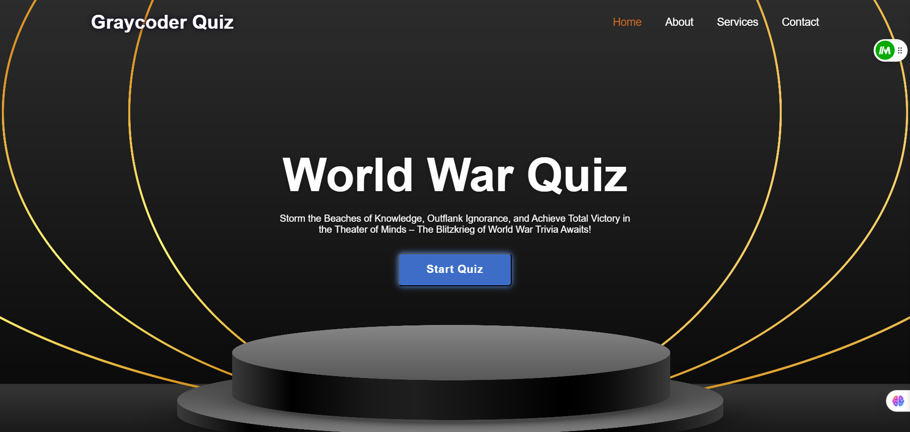

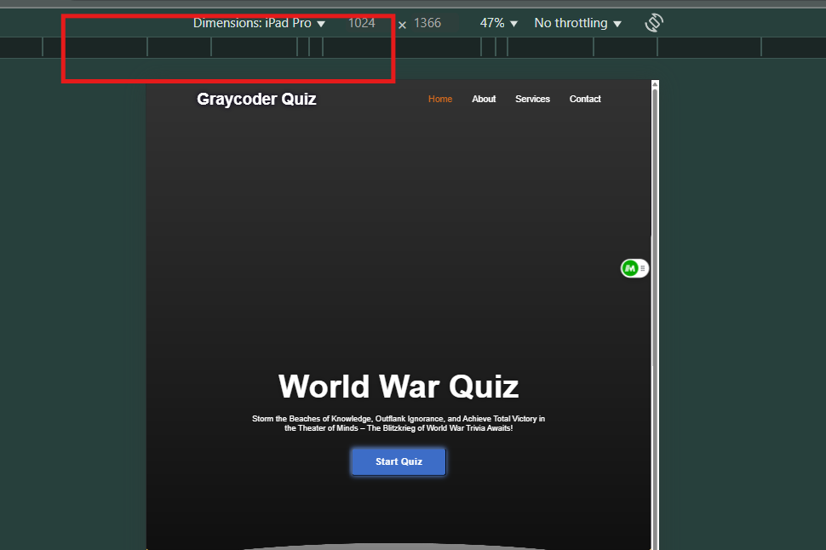
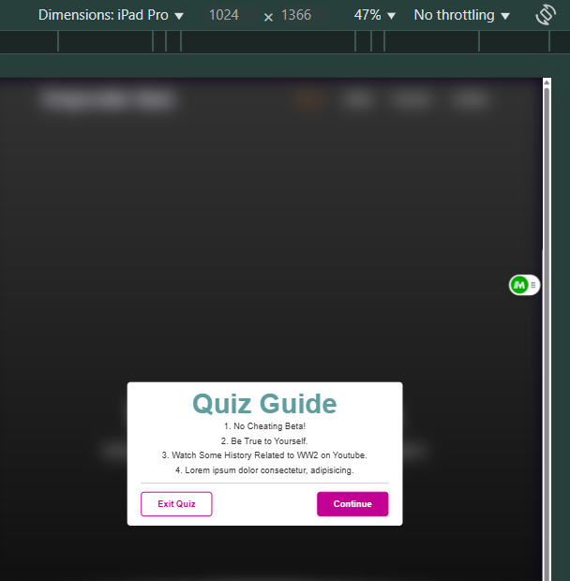
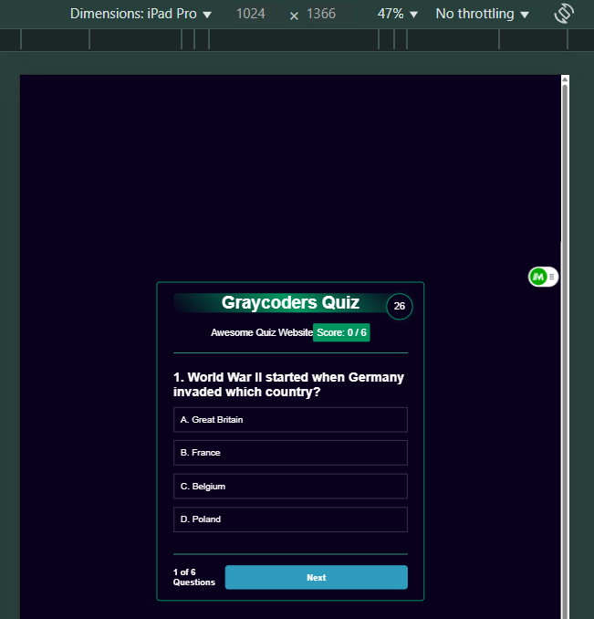

Quiz Functionality:

- The quiz should have multiple-choice questions.
- Users are able to select an answer and submit their response.
- instant feedback is provided on whether the answer is correct or incorrect.
- Final Score is shown in the end with some bonus on solving in time.

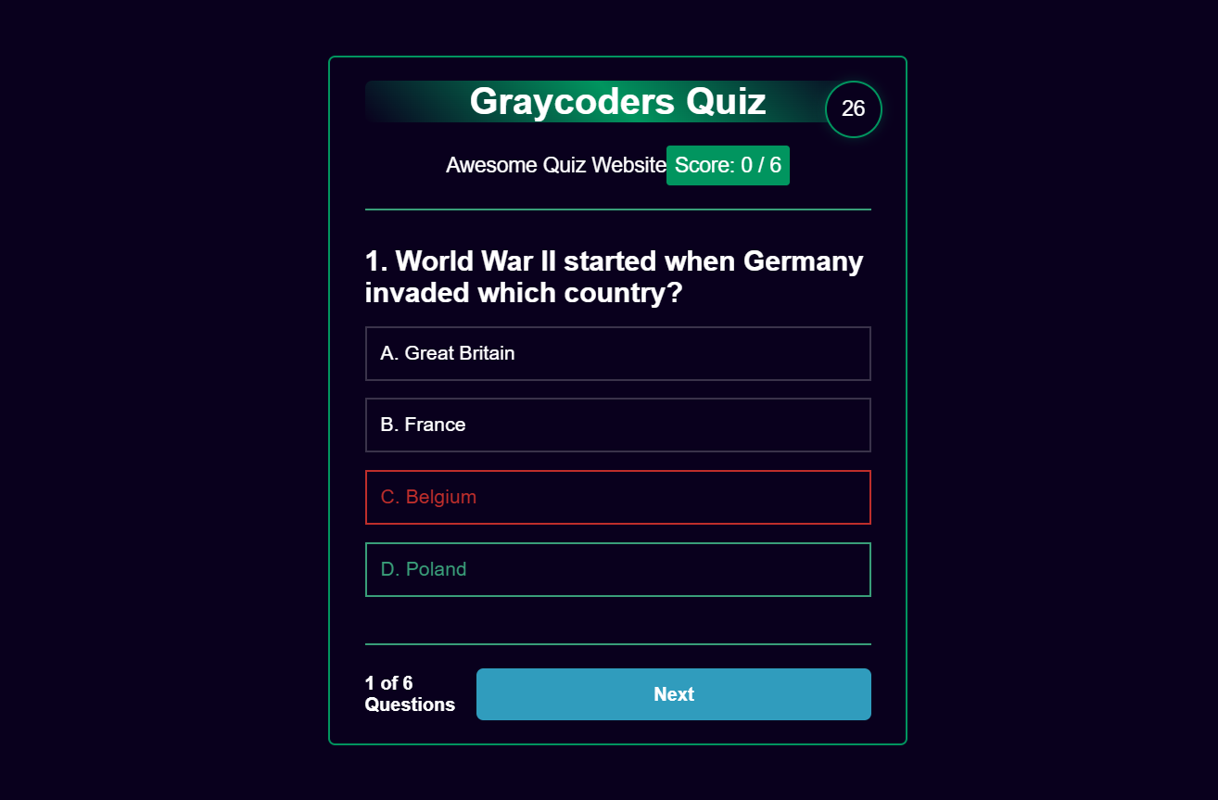

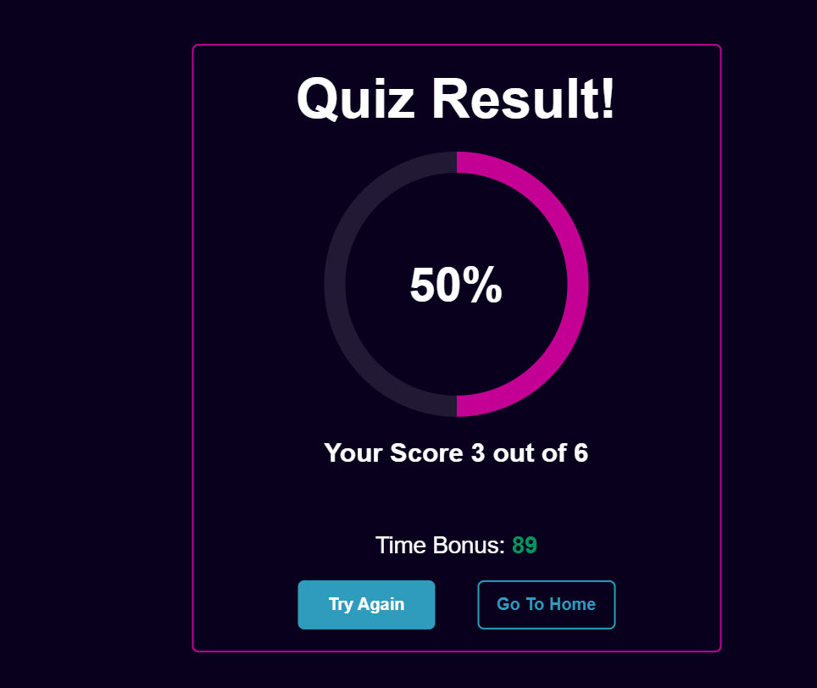
Interactivity using JavaScript:
- Javascript is used to handle user responses dynamically by help of classes.
- Scores and Scores Header are also dynamic. (means if we add more questions to the questions array – it will update automatically)
- Event Listeners like onclick are used to capture user response to highlight right and wrong.
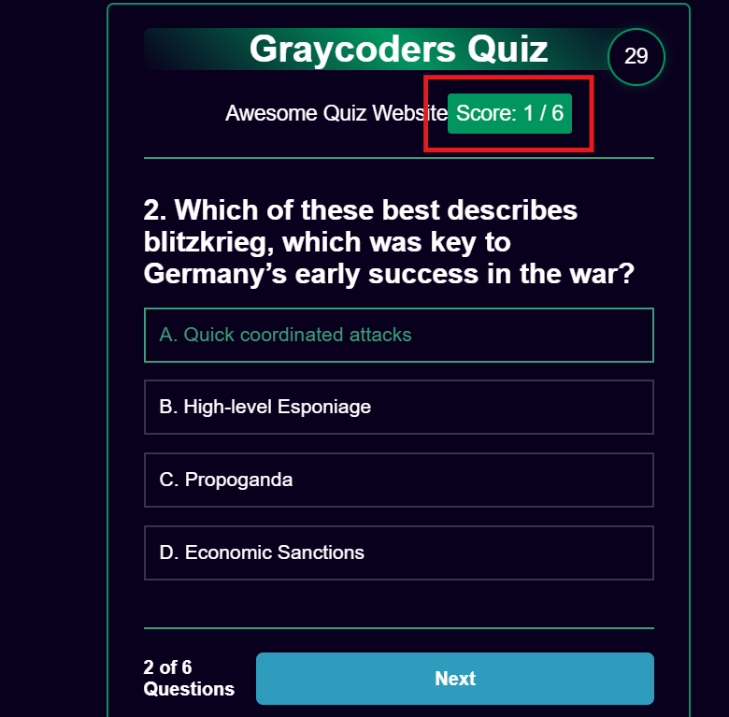

HOSTED URL:
- Hosting done using Firebase.
https://graycoders-quiz.web.app/

